**Youtube Analysis**

*William Stoddard, David Schwartz, Alex Clayton*

**Description:**

Our project is an analysis of YouTube channel popularity and success of categories of YouTube content based on country. We plan to sort through the top 1000 YouTube channels based on subscriber amount to analyze popularity of YouTube content

**Questions:**

* Which genres of content are most popular in general?
* Do certain countries have a most popular genre of youtube content?
* Is there an even distribution of successful creators among technologically advanced countries?
* Do larger countries have more successful creators?

**Data:**

<https://www.kaggle.com/datasets/nelgiriyewithana/global-youtube-statistics-2023>

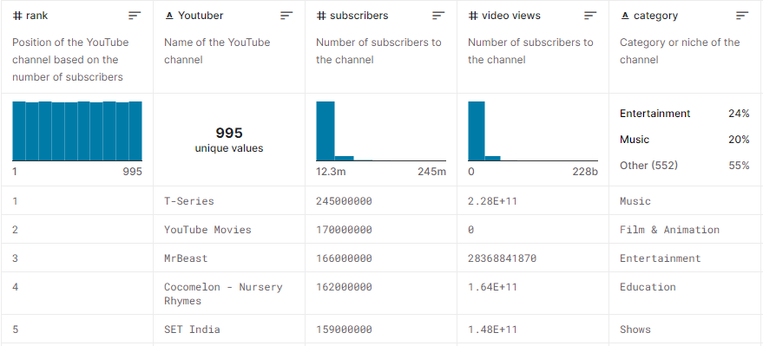

Other notable columns include: Uploads, Country, Video views rank, Country rank, Channel type rank, Video views for the last 30 days, Subscribers for the last 30 days, Highest monthly earnings, Highest yearly earnings

**Github URL:** https://github.com/davsssss/project3